Purpose Adjunct

✅ What Is a Purpose Adjunct?
# Source: AI Source: Provided by: [Data Path: Persons Table -> ID Column: 1, Name_En Column: Motasem Essam] -> From: [Chatgpt (GPT-4-turbo)] on [8/6/2025]
A purpose adjunct is a word, phrase, or clause that explains the goal or intention behind an action. It tells why something is done — specifically, for what purpose — and adds extra, non-essential detail to the verb.
It answers the question:
- For what purpose?
- Why (with intent)?

🔸 Common Forms of Purpose Adjuncts:
# Source: AI Source: Provided by: [Data Path: Persons Table -> ID Column: 1, Name_En Column: Motasem Essam] -> From: [Chatgpt (GPT-4-turbo)] on [8/6/2025]
- Infinitive Phrases: to win, to help her, to get better
- Prepositional Phrases: for the purpose of, for the sake of
- Subordinate Clauses: so that, in order that, for the purpose that

🔸 Examples of Purpose Adjuncts in Sentences:
# Source: AI Source: Provided by: [Data Path: Persons Table -> ID Column: 1, Name_En Column: Motasem Essam] -> From: [Chatgpt (GPT-4-turbo)] on [8/6/2025]
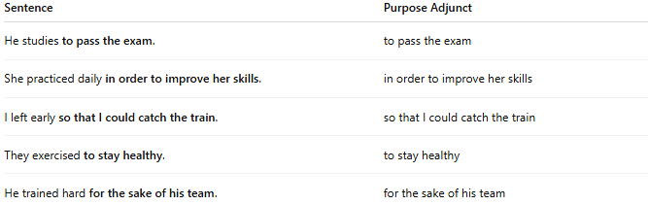
Sentence | Purpose Adjunct
He studies to pass the exam. | to pass the exam
She practiced daily in order to improve her skills. | in order to improve her skills
I left early so that I could catch the train. | so that I could catch the train
They exercised to stay healthy. | to stay healthy
He trained hard for the sake of his team. | for the sake of his team

🔸 Position in the Sentence:
# Source: Chatbot (GPT-4-turbo) at [8/6/2025]
- Initial: To impress the judges, she performed flawlessly.
- Final: She performed flawlessly to impress the judges.

🔸 Reminder:
# Source: AI Source: Provided by: [Data Path: Persons Table -> ID Column: 1, Name_En Column: Motasem Essam] -> From: [Chatgpt (GPT-4-turbo)] on [8/6/2025]
A purpose adjunct is optional—it enhances the sentence by revealing intention, but is not required for grammatical correctness.
🟢 "She studied."
🟡 "She studied to pass the exam." → Purpose adjunct adds motive

